Authentication(default and keycloak)

**Flask**

Default Authentication:

Flask uses Flask-login as default authentication

We uses login and signup for creating user for default authentication using Flask-login

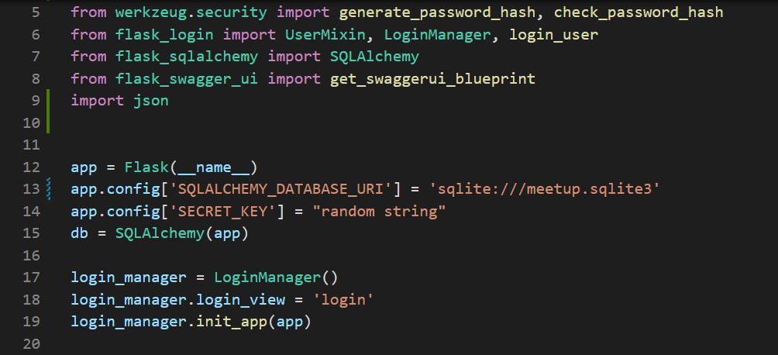

Login:

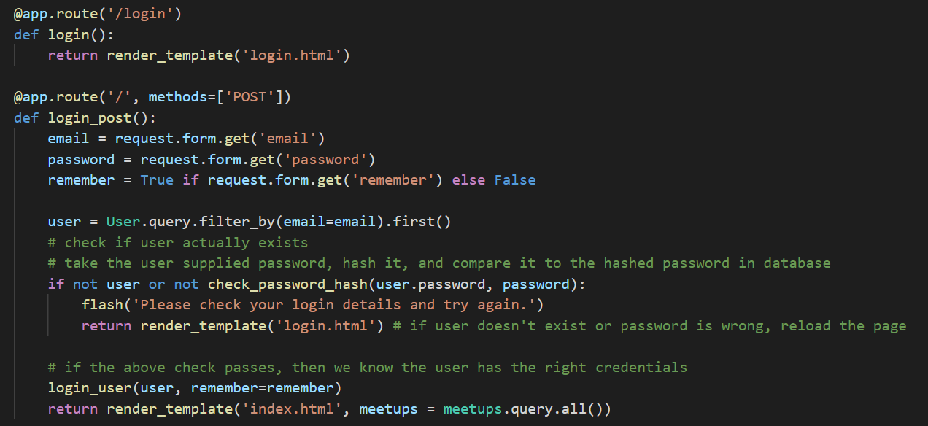

Here is our login part where we are authenticating user by using login_user default method of flask-login

Signup:

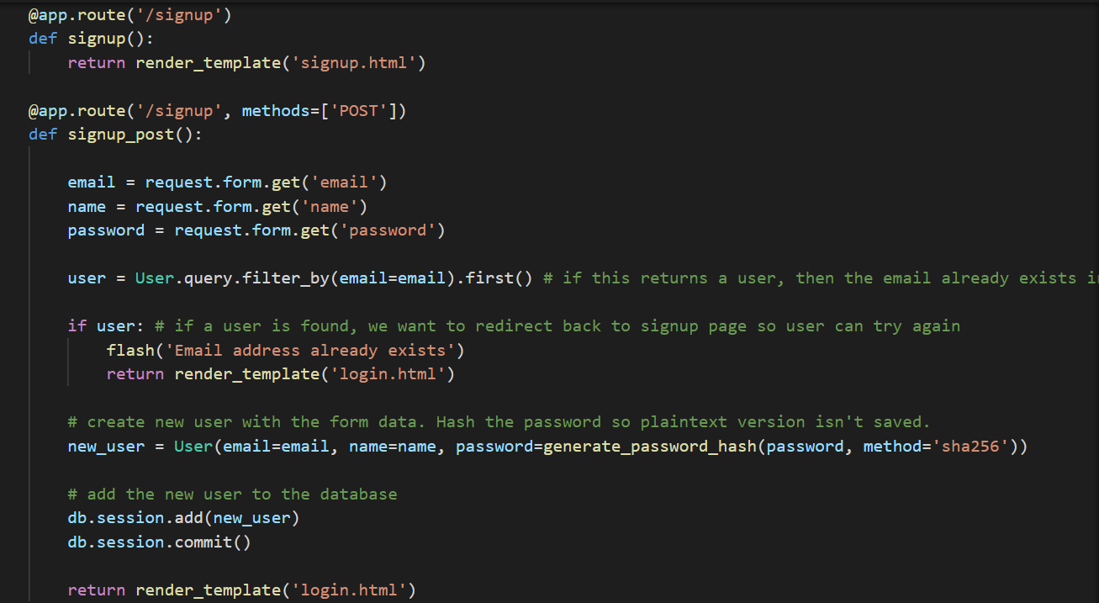

For Authentication the role is played by login method for default authentication

Keycloak Authentication:

* What is keycloak Authentication?
* **Users authenticate with Keycloak rather than individual applications**. This means that your applications don't have to deal with login forms, authenticating users, and storing users. Once logged-in to Keycloak, users don't have to login again to access a different application. This also applied to logout

There are some several procedure for authenticating using keycloak

1. Download keycloak from <https://www.keycloak.org/downloads>
2. Need to install OpenJDK <https://www.keycloak.org/getting-started/getting-started-zip>
3. Run keycloak using(for windows) – bin\kc.bat start-dev
4. Start the interface using loclhost:8080
5. After starting the interface

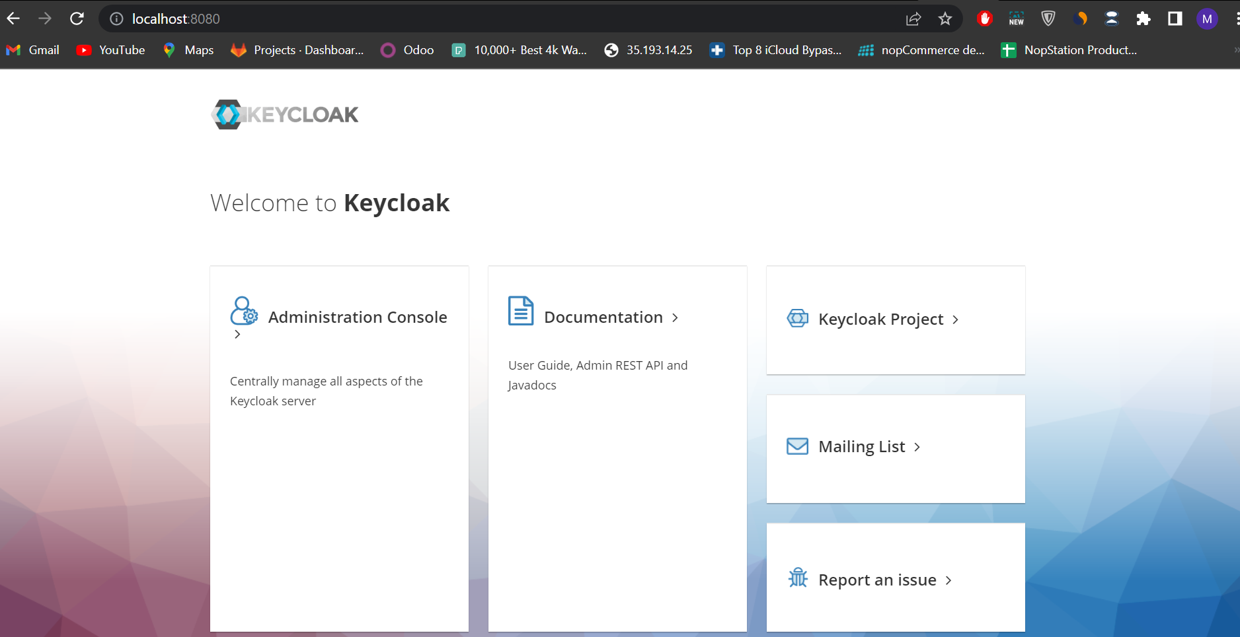

After starting the interface goto administration console, create account for administration console and this interface will come

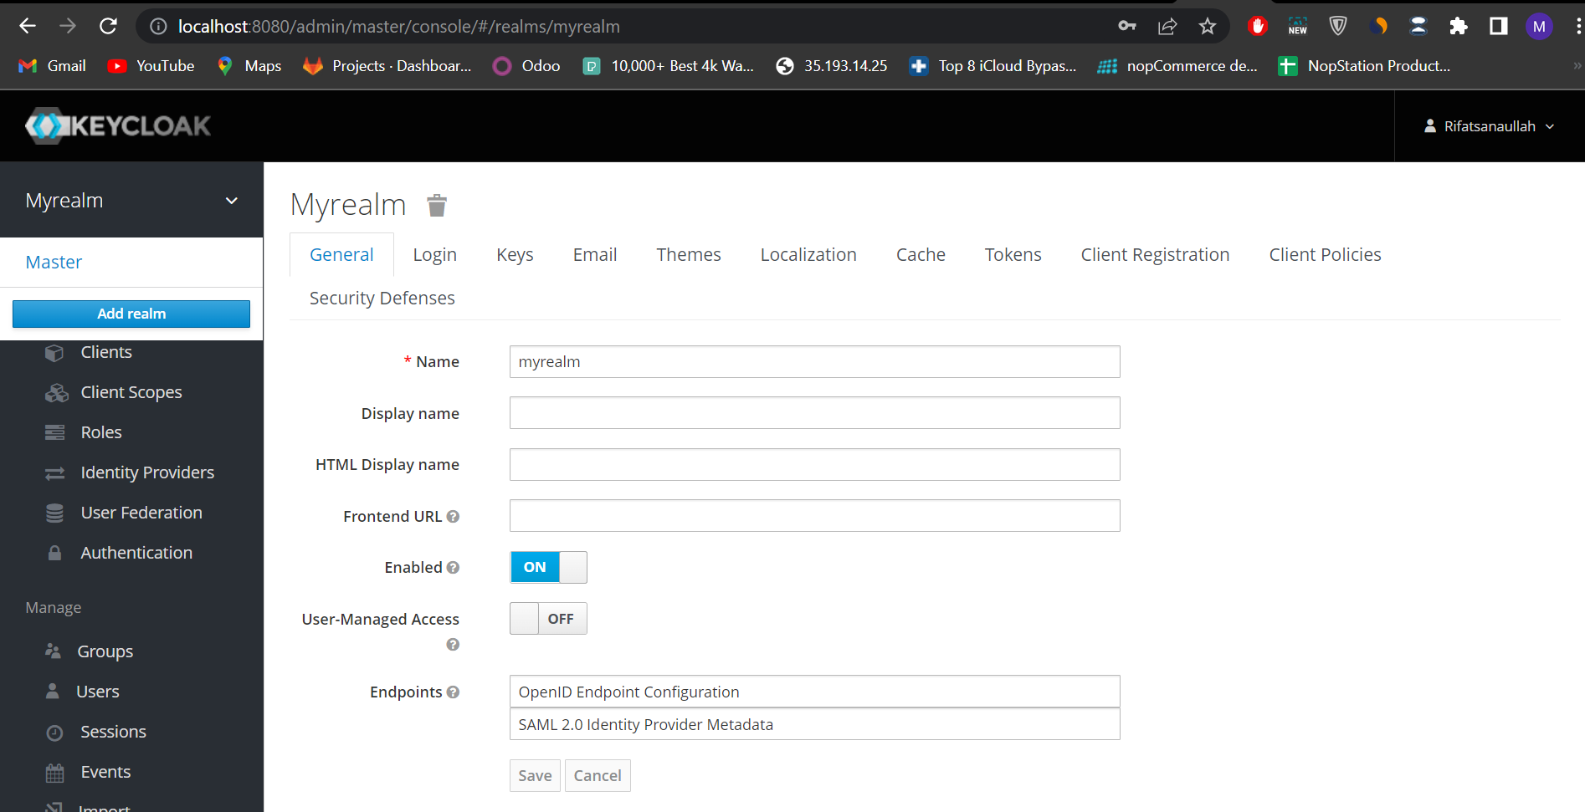

After that create a realm, create users and create client

Read this for detail proceed - <https://docs.axway.com/bundle/EBICSClient_11_allOS_en_HTML5/page/install_and_configure_keycloak_server.html>

After configuring keycloak server

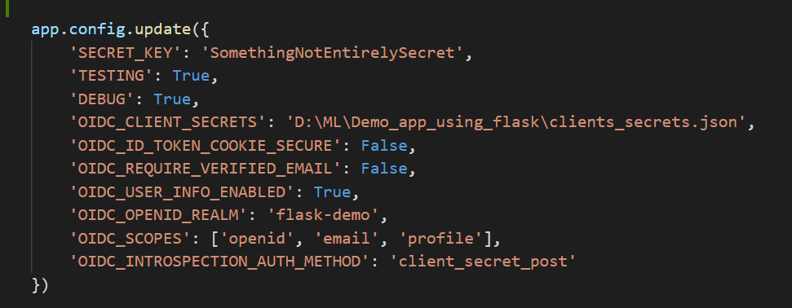

Config this in app

Then use the route to use keycloak, I used in ‘/private’ route and hello_me function to authenticate user through keycloak

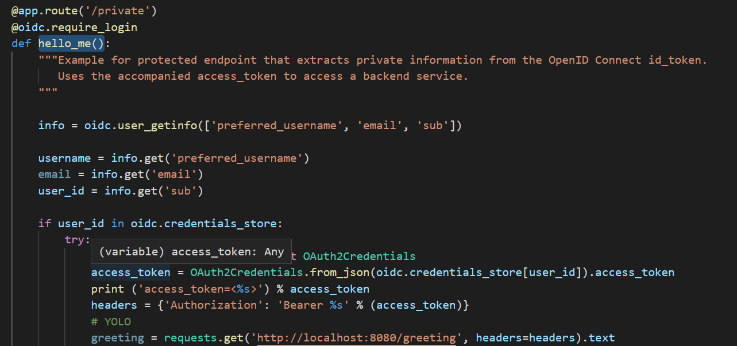

This will do the rest of authentication using keycloak.

For keycloak the important part is OIDC client secret: which one I named as clients_secrets.json

This client_secret,json needs some variable for connecting with keycloak which can be found in

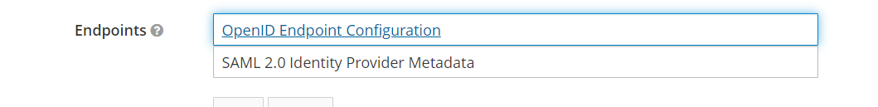

Myrealm section(I have created this manually before)

Then we can use keycloak authentication in our app

**Django:**

Default authentication in Django:

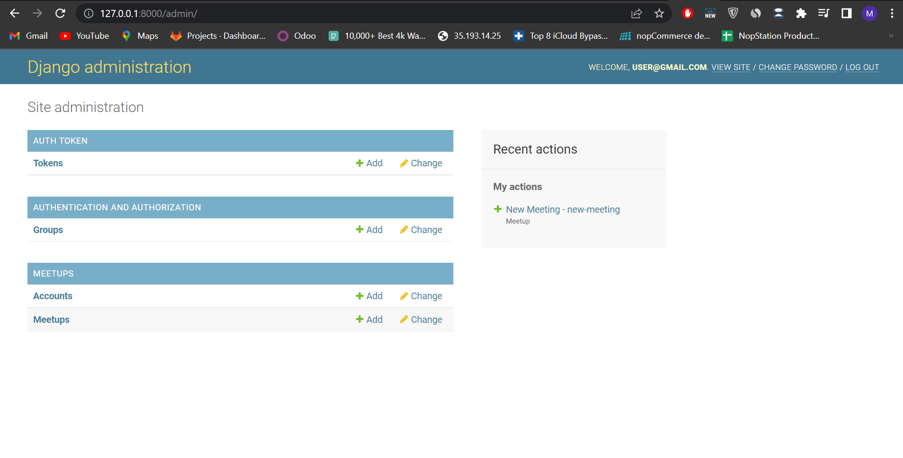

Go to /admin path to configure the account in Django Administration

When we will create superuser it will create a account which will be needed for authentication

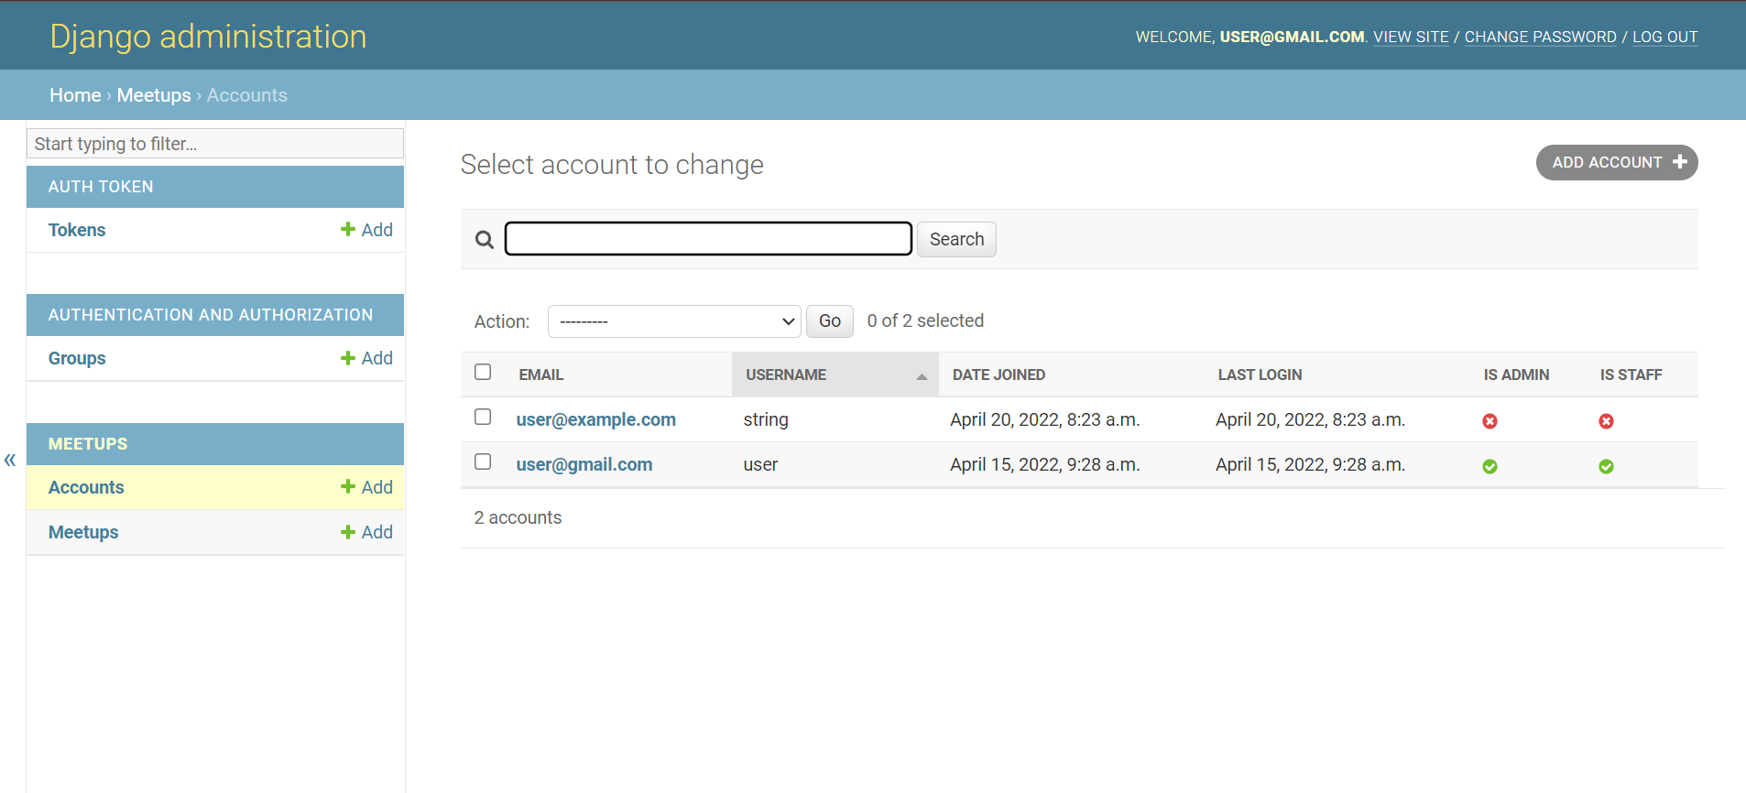

We can create user by simply use add account button or from code,

After creating each user token will generate for indivisual user which will need to get authorization



Reference:

1. <https://flask-login.readthedocs.io/en/latest/#:~:text=By%20default%2C%20Flask%2DLogin%20uses,to%20set%20a%20secret%20key>.
2. <https://keycloak-client.readthedocs.io/extensions/flask.html>
3. <https://docs.axway.com/bundle/EBICSClient_11_allOS_en_HTML5/page/install_and_configure_keycloak_server.html>
4. <https://developer.mozilla.org/en-US/docs/Learn/Server-side/Django/Authentication>
5. <https://pythonbasics.org/flask-login/>